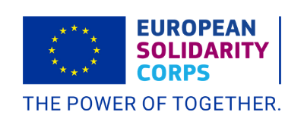
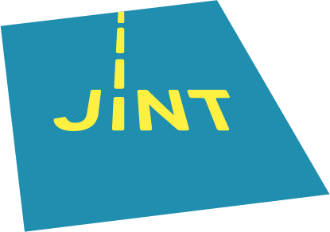
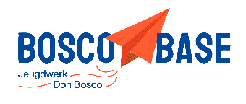
Bosco Base vzw
Naamsesteenweg 37
B-3001 Heverlee

Individual Volunteering Long Term Boarding School Don Bosco Ganshoren.
September 2026 - July 2027 Brussels, Belgium

Don Bosco Ganshoren is a Boarding School that hosts European volunteers to help and support their daily activities during the school year. The period that you would be joining the project goes from beginning of September until the end of July. This is a place where young people and children aged 6-21 are hosted during a period of time due to familiar environmental issues. This way they are supported by the Salesian Sister of Don Bosco. The boarding school welcomes around 80 young people from all social backgrounds. You role is a supporting role, where you will become a staff member and share activities; workshops and your everyday life with the children and youth of the boarding school.
Objectives of the activity:
- The participants learn about the reality of youth and children in vulnerable situations in the city of Brussels .
- The participants develop their youth work competences in a practical way through the development of their own learning project.
- The participants strengthen their linguistic competences in French.
- The participants improve their non-formal education skill as well as their youth work skills.
- The participants learn about the Don Bosco pedagogy and how is it implemented in Flanders and in Brussels.
Who can apply?
If you are interested to learn about Don Bosco non formal education in Flanders, then you are more than welcome. However there are a couple of things that we would take in consideration:
- 18-30 years old.
- Knowledge of English, but good level of French since it is the main language of the activity.
- Experience working with children as an animator or as a youth worker in Don Bosco organisations (outside also welcome).
- Open and motivated to live a year among other nationalities and cultures.
IMPORTAN: If you come that needs a VISA, lets us know so we can start the procedure as soon as possible. Also, you will need a sending organisation so we can together help you out with the visa procedure
What will they do:
- Support with conversation and games to children and youth in the boarding school.
- Assist and be there if there are activities during the year.
- Support the homework and educational activities.
- Plan and supervise educational, creative, relaxing activities in and outside the boarding school.
- Regular meetings with the rest of the team.
- Attend organisational events and activities from Bosco Base (with previous approval) by the hosting organisation.

Practicalities:
Since it is a European Solidarity Corps project, the participants will not have to pay for costs for accommodation, transport during the activity and food, they will also receive pocket money. Transport to Belgium might differ depending on the travel distance from the country of origin until the place of the activity. VISA costs will also be reimbursed 100% if the original receipts are provided.
For any other questions, please contact: celia.aller@donbosco.be

